

**Blood Bank Management System**

**Group: G-42**

# 

# ***Students*:**

**· Srajit Jain 19UCS069**

**· Vaibhav Singhal 19UCS018**

**· Daksh Sharma 19UCS065**

**· Pearl Kothari 19UCS071**

**Tables:**

* **user**
* **donor**
* **bloodbank**
* **receiver**
* **staff_transaction**

user(**UserID**,username,emailID,Address,phonenumber,password,post,Date);

donor(**UserID,**BloodGrp,AnyDisease,Quantity,Disease,Date,phonenumber);

* FK_1: **UserID** references user(**UserID**);

bloodbank(BloodGrp,Quantity);

receiver(PatientID,PateintName,PateintAge,StaffID,BloodGrp,volume,contactNumber,Date);

staff_transaction(StaffID,Date,status);

* FK_1: StaffID references receiver(StaffID);
* **Tables**: 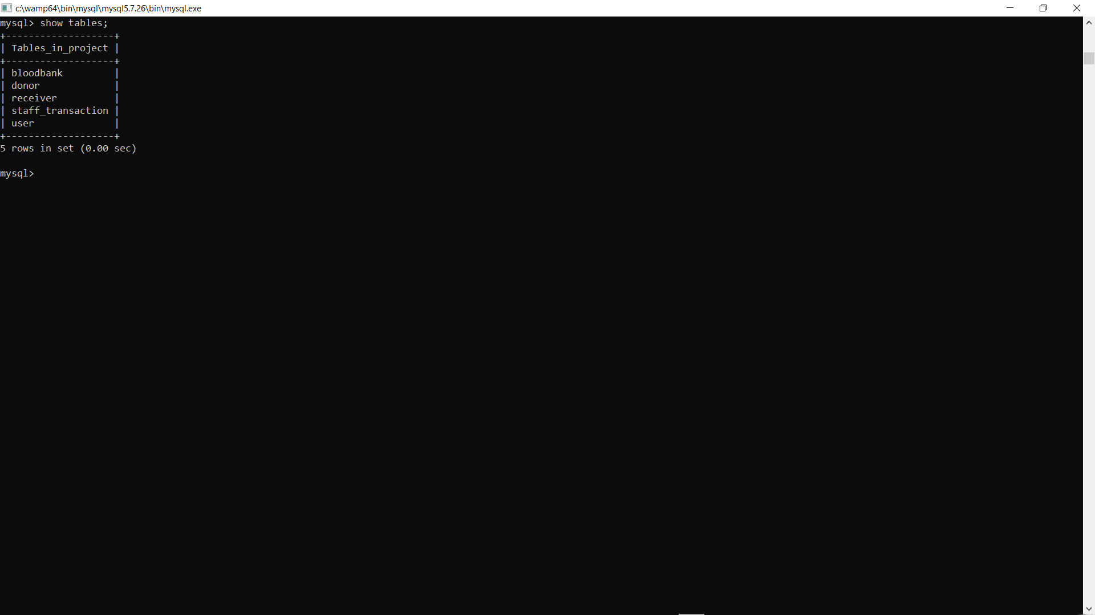
* **All Tables Description:**
  + ***user***

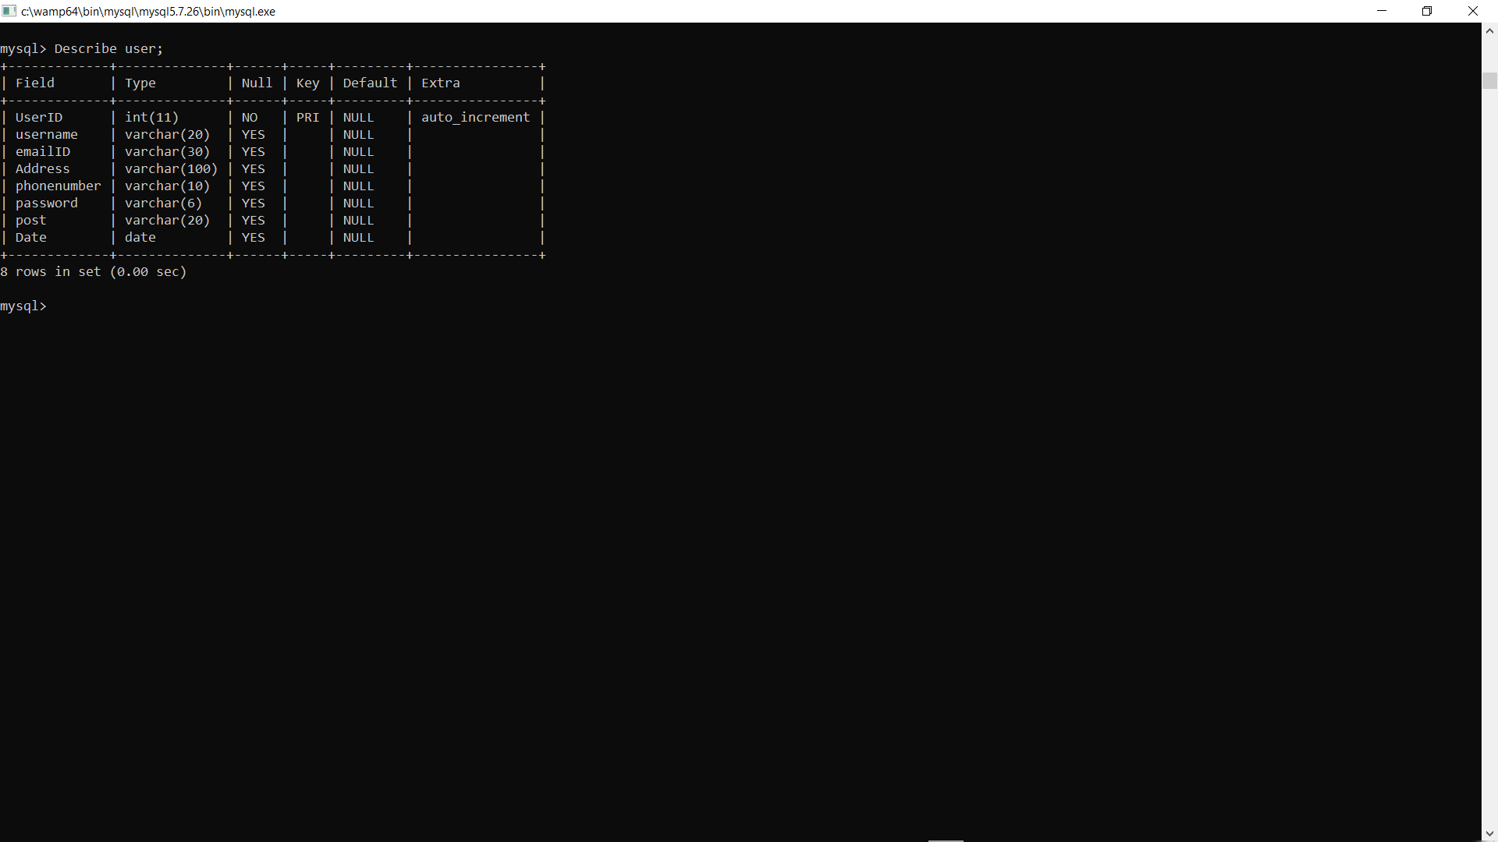

* + ***donor***

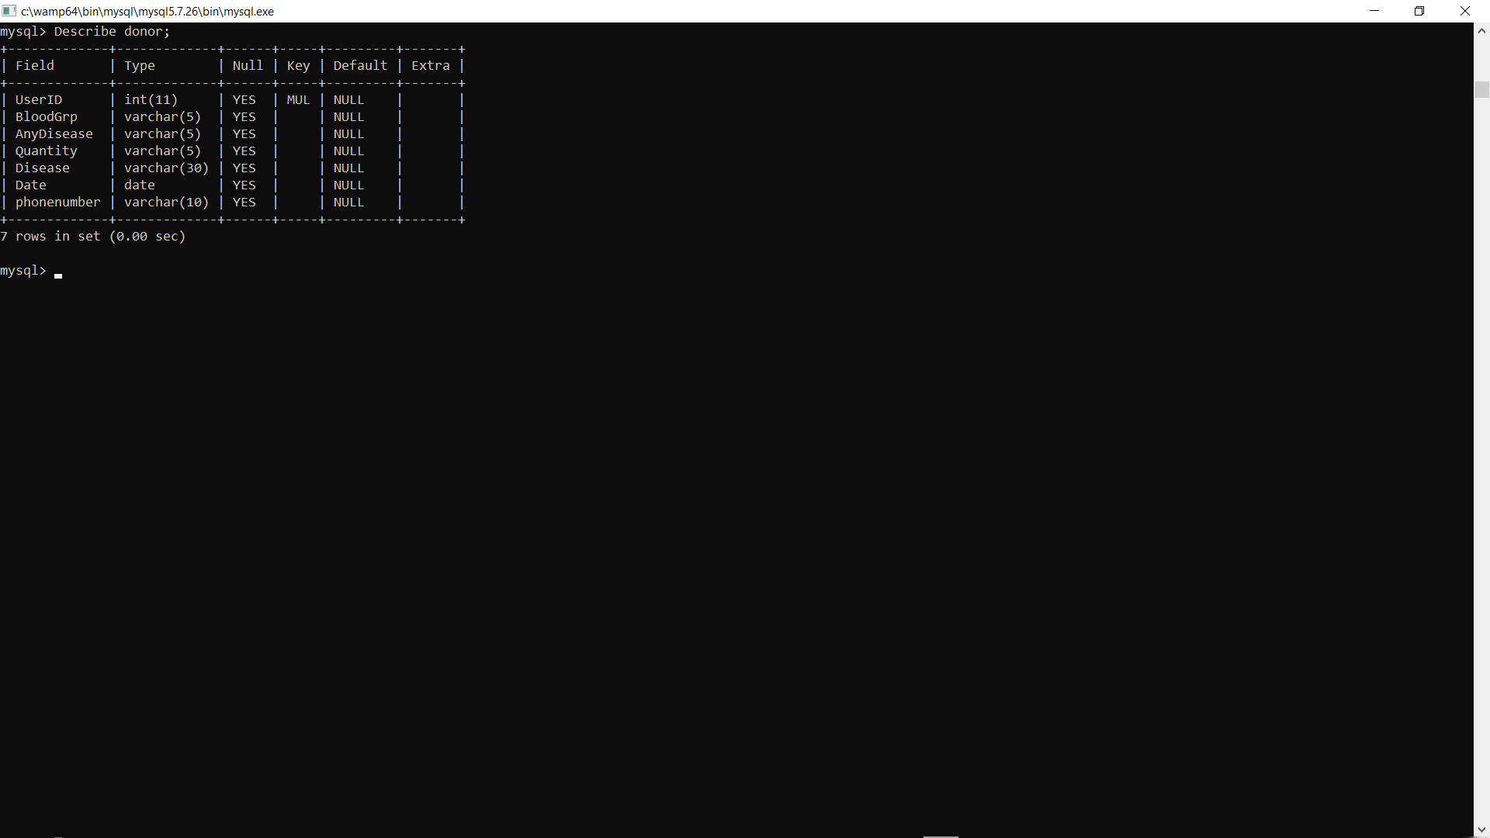

* + ***bloodbank***

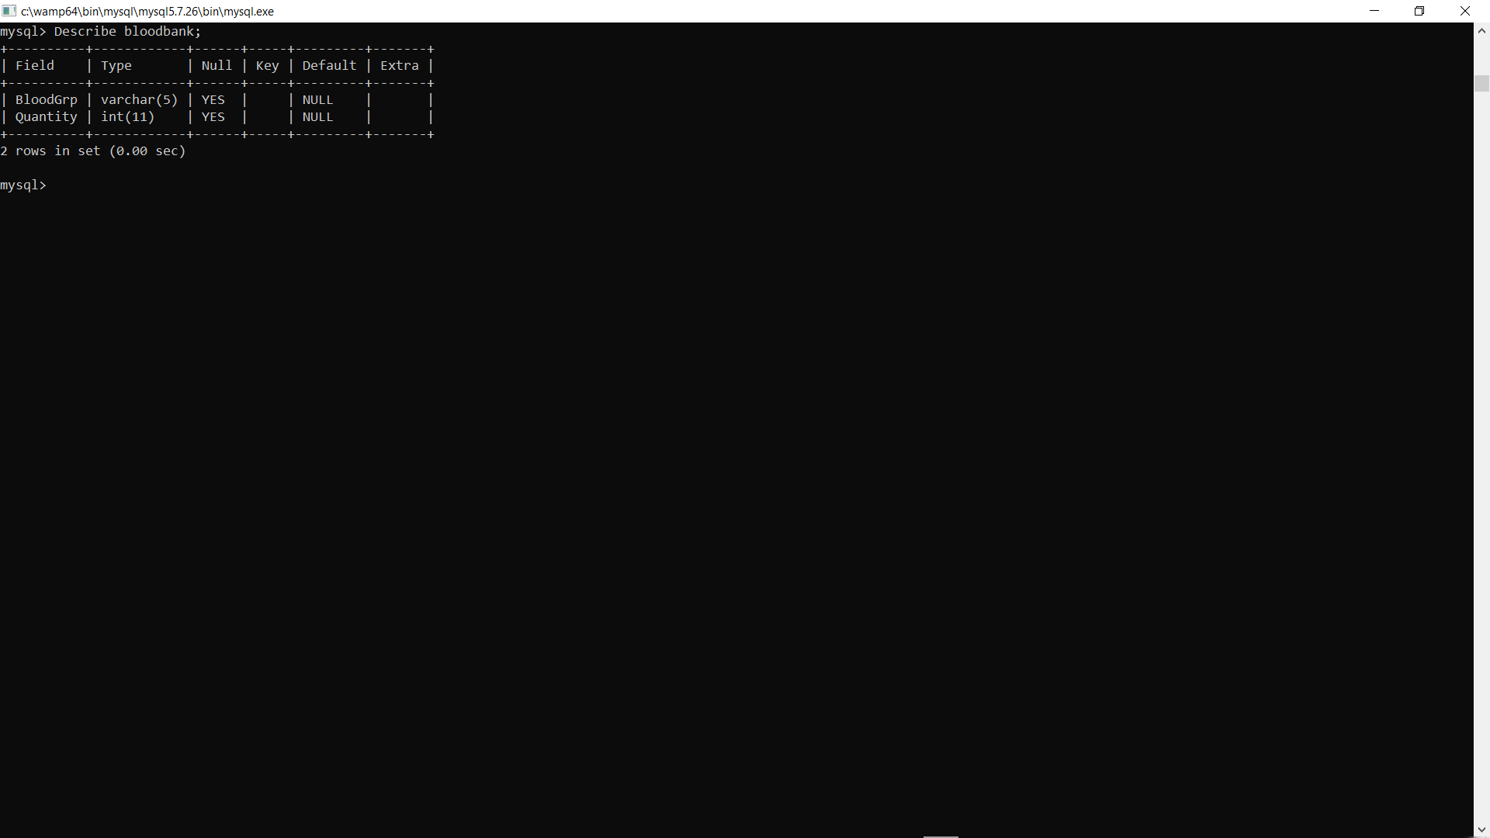

* + ***receiver***

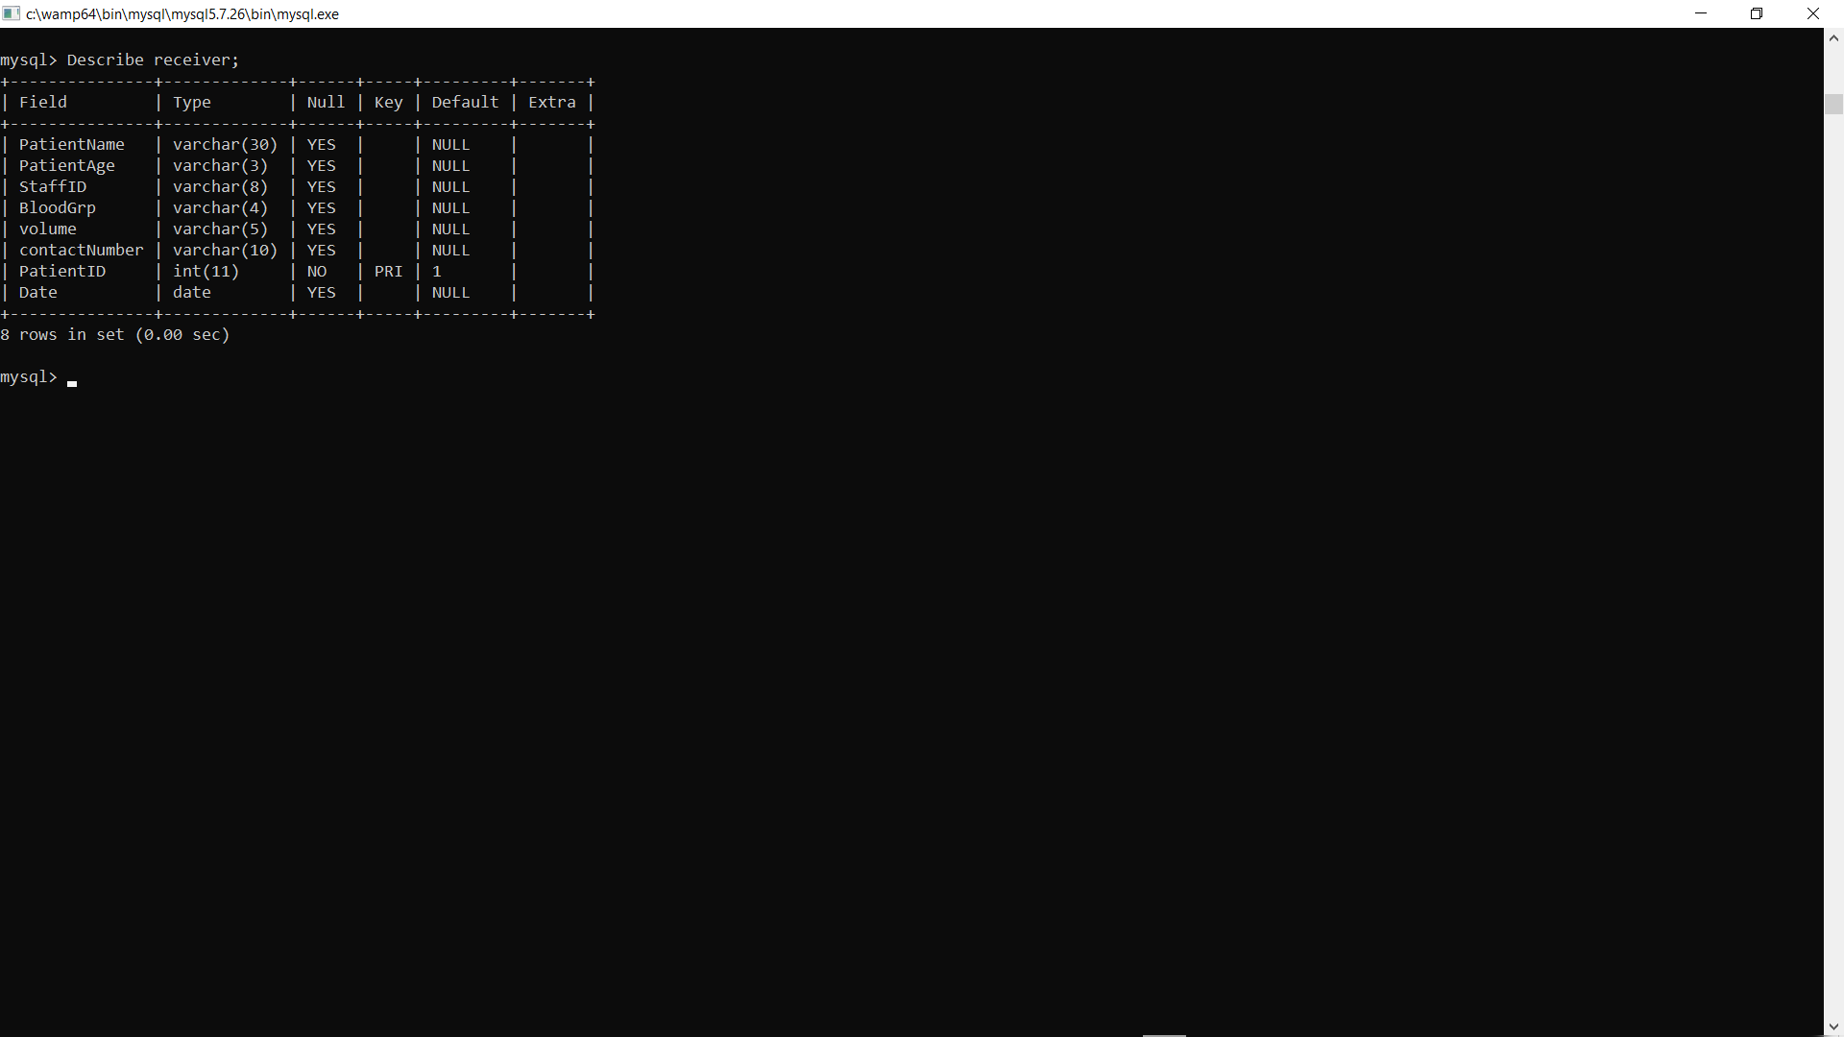

* + ***staff_transaction***

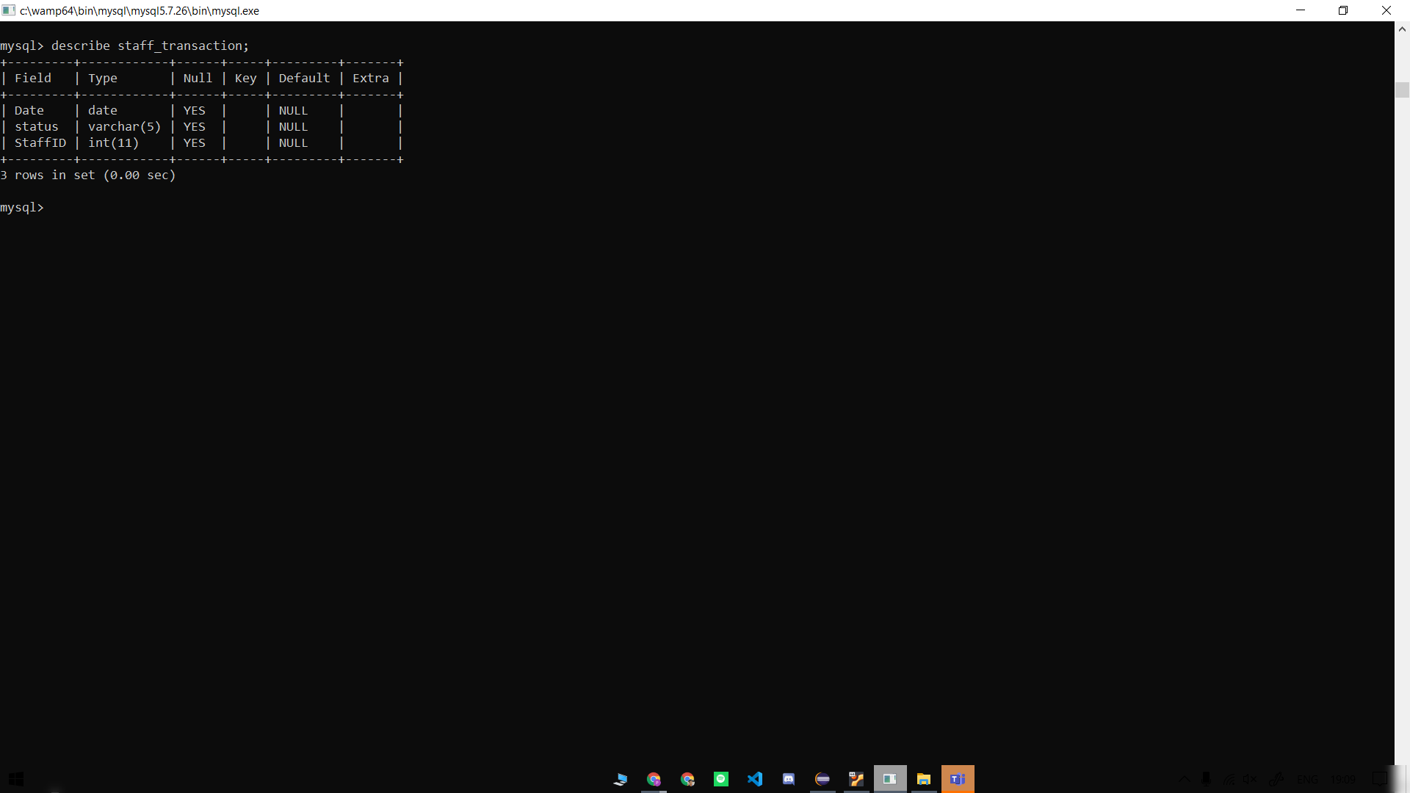

* ***Adding 4 donor and 1 staff in user table:***

insert into user (username,emailID,Address,phonenumber,password,post) VALUES

('pearlkothari','[pearlkothari2@gmail.com](mailto:pearlkothari2@gmail.com)','anand mohalla oldcity kishangarh','9521074578','1234','Donor'),

('DakshSharma','[dakshsharma@gmail.com](mailto:dakshsharma@gmail.com)' ,'332,comet society new delhi','9192192199','123','Donor'),

('vaibhavsinghal','[iamvs@gmail.com](mailto:iamvs@gmail.com)','apex apartment mumbai','9000000000','090909','Donor'),

('srajit jain','[hello@gmail.com](mailto:hello@gmail.com) ','govindam apartment mumbai','6521078990','090909','Donor'),

('lexi','[lexi@gmail.com](mailto:lexi@gmail.com)’ ,'lightyear apartment mumbai','9090909110','090909','Staff');

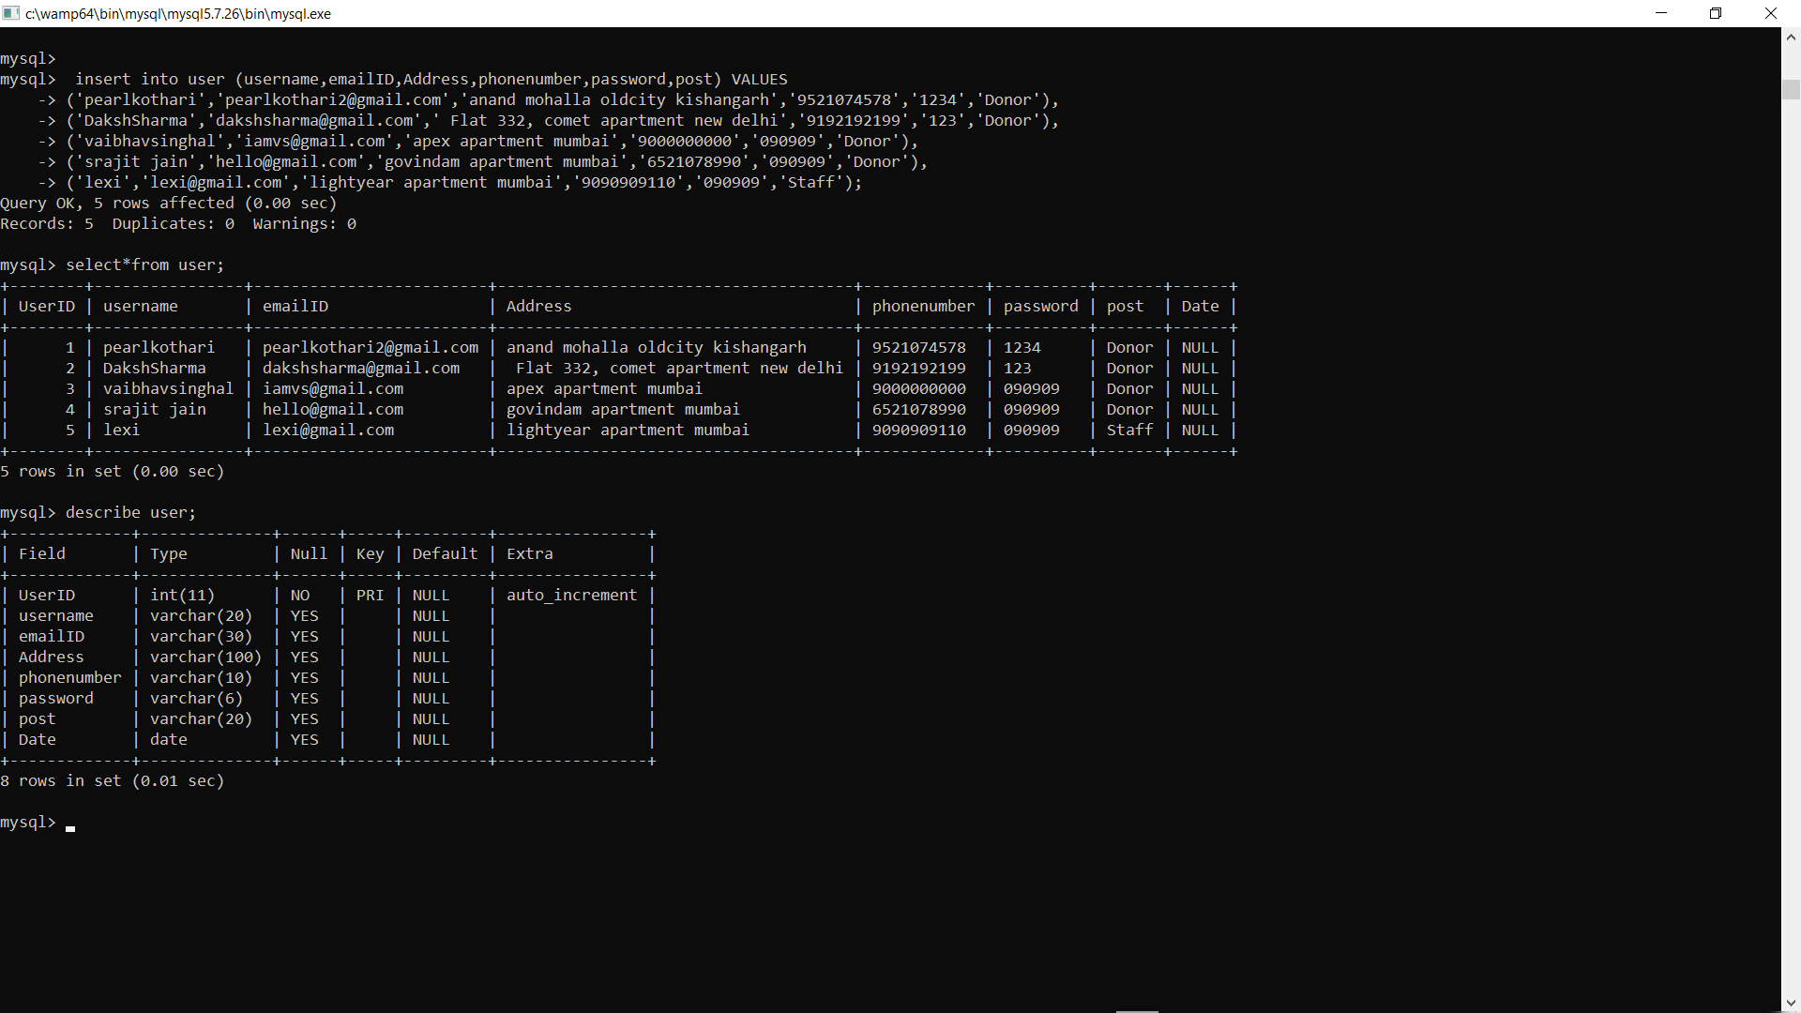

* **Inserting all blood group in bloodbank with initial quantity = 0:**

insert into bloodbank (BloodGrp,Quantity) Values ('A+',0),('B+',0),('O+',0),('AB+',0),('AB-',0),('O-',0),('B-',0),('A-',0);

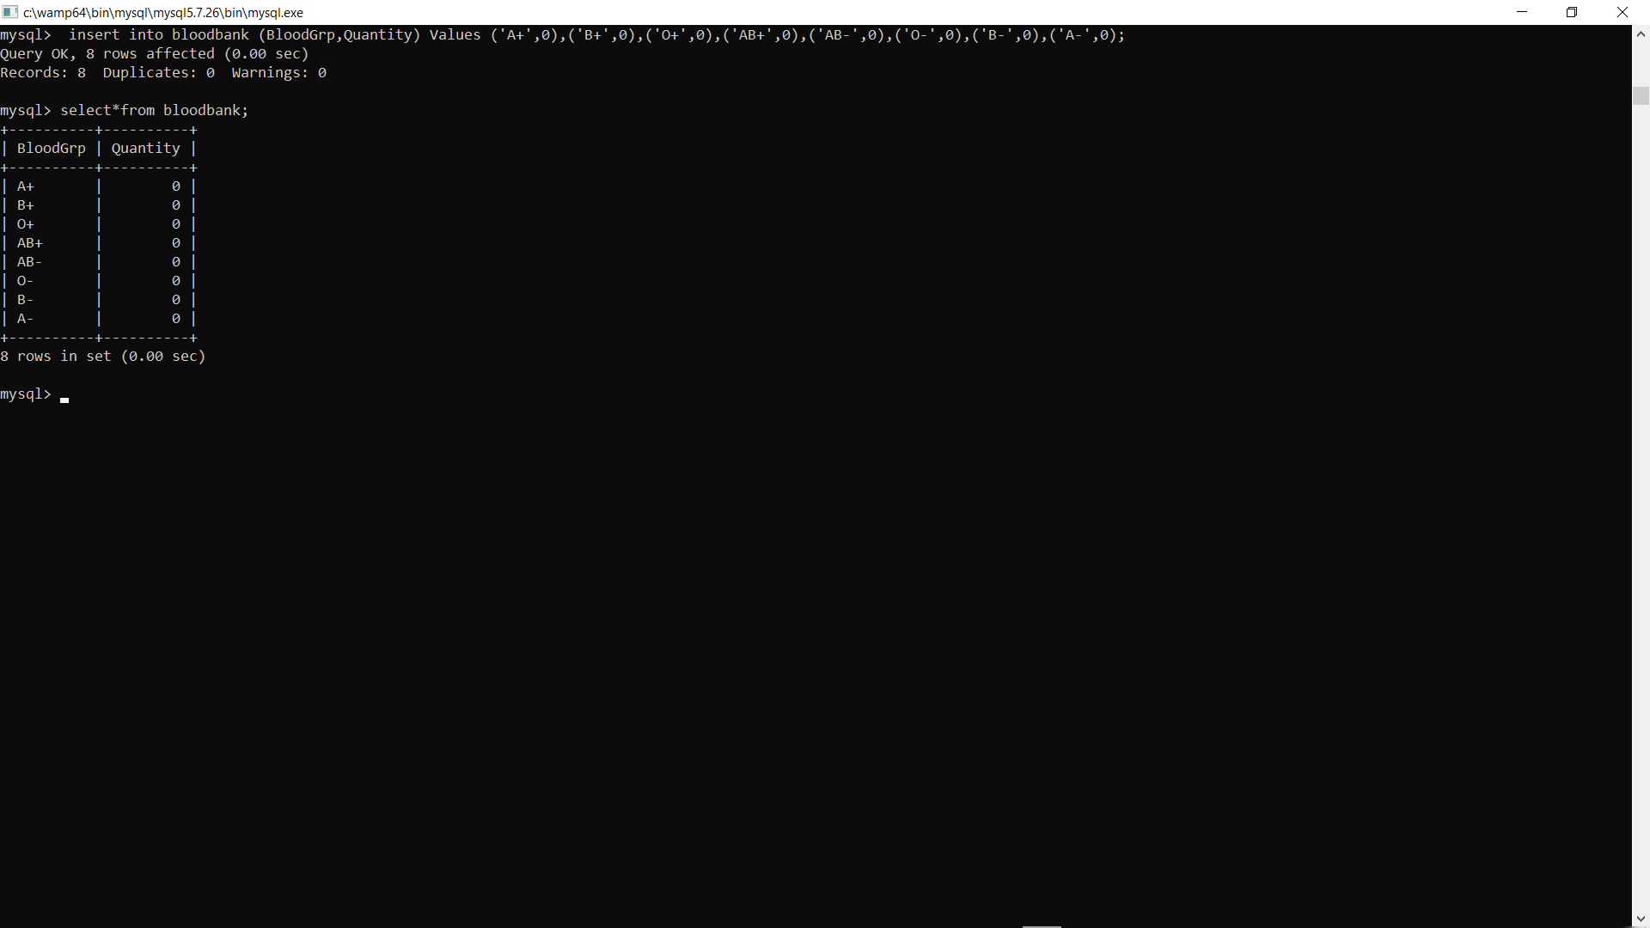

* **Get user with phonenumber = XXXXXXXXXX**

select*from user where phonenumber=XXXXXXXXXX;

For Example : Search user where phone number=9521074578;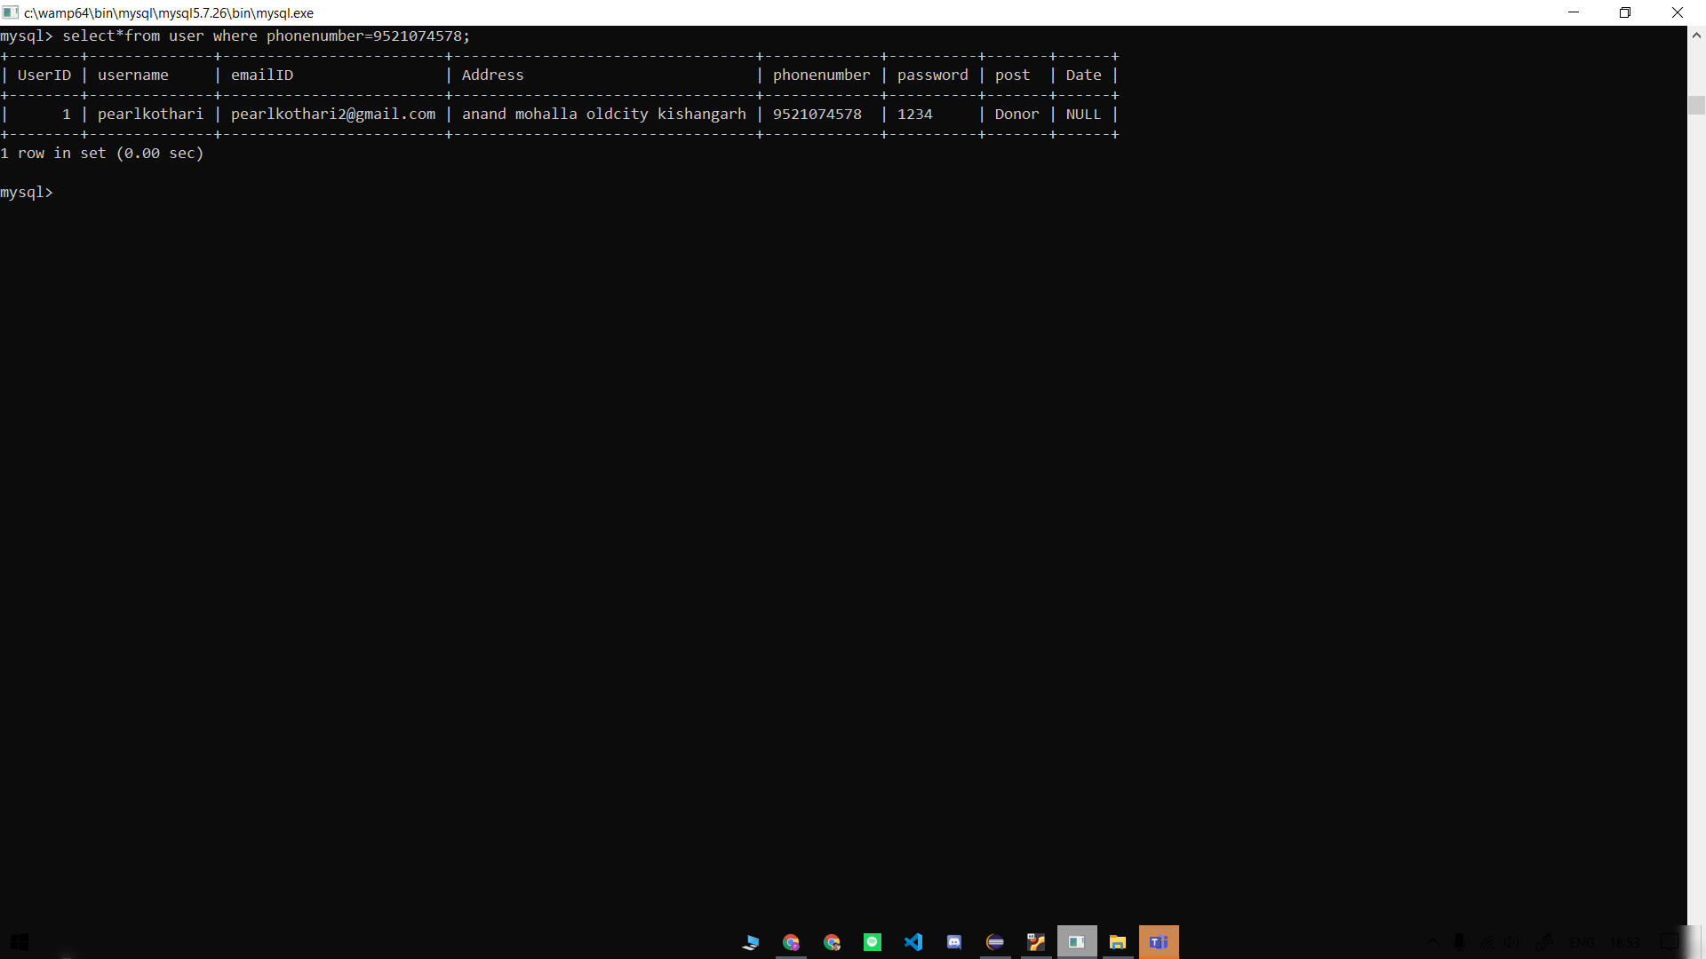

* **Forgot Password in login page:**

**Finding the user password where userID=XXXXXX and phonenumber=XXXXXXX:**

For Example: Search User Password where

phone number=9521074578 and UserID=1;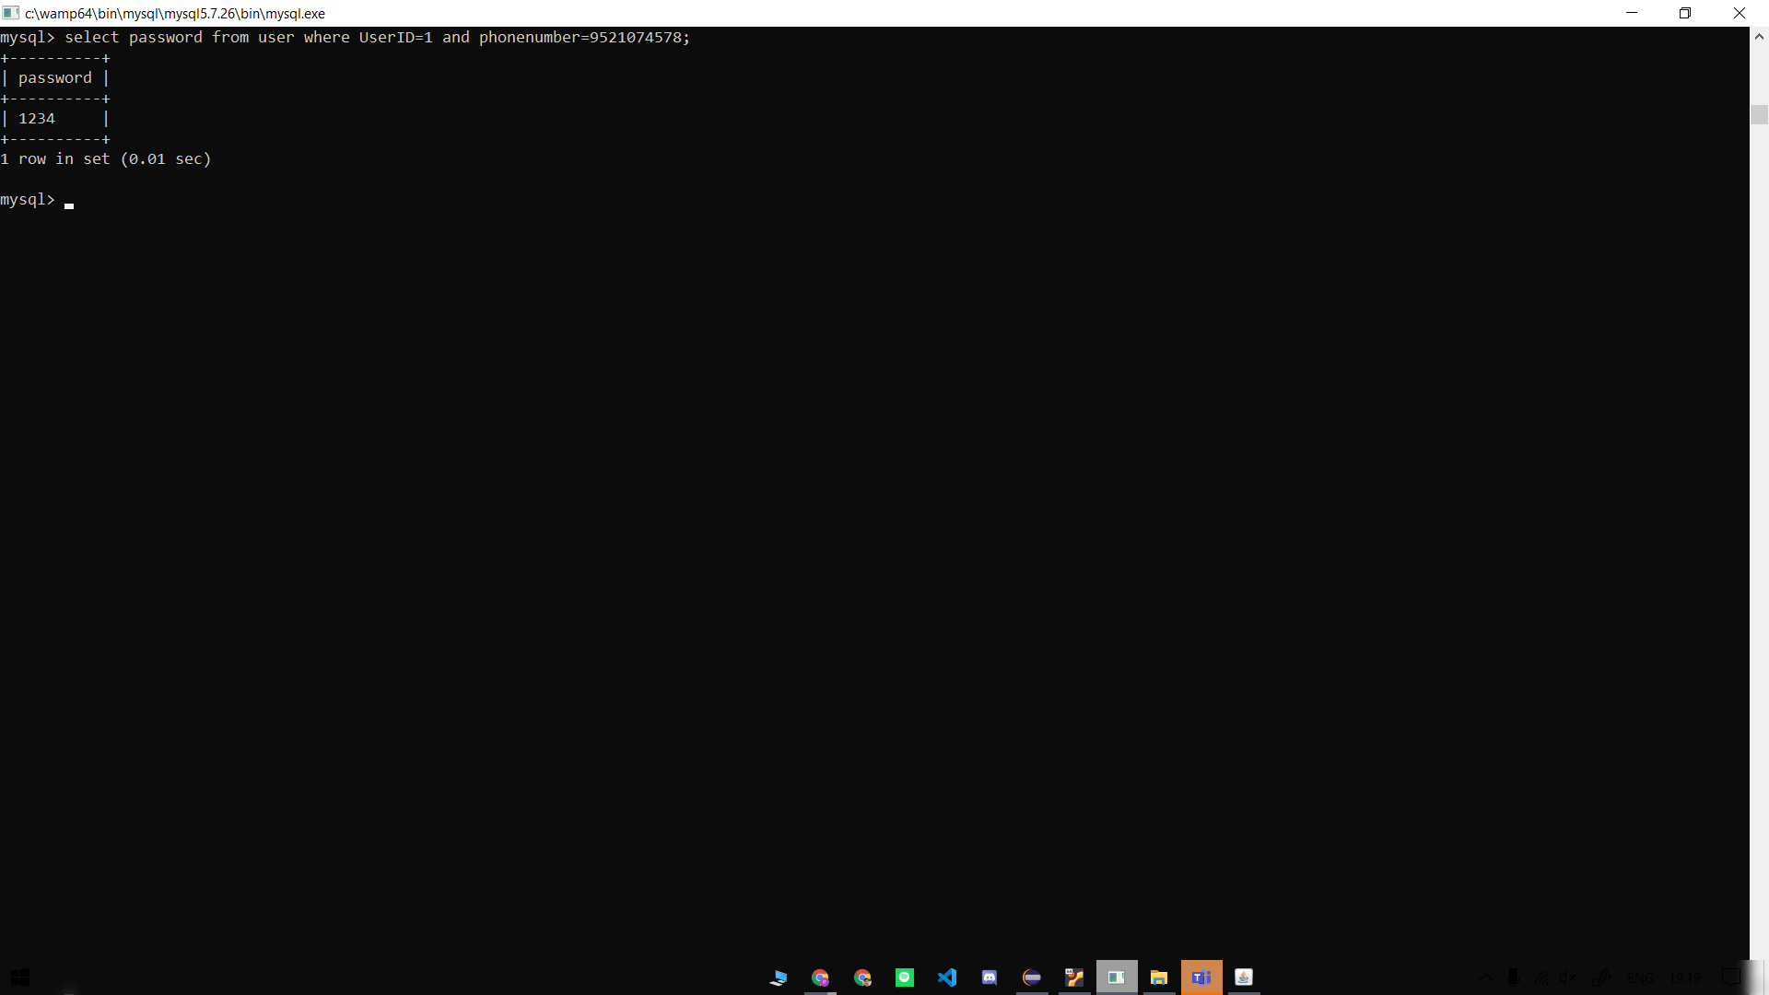

* **Reset Password of Donor:**

UPDATE user SET password=XXXXXX where UserID=XXXX and password=XXXXXX;

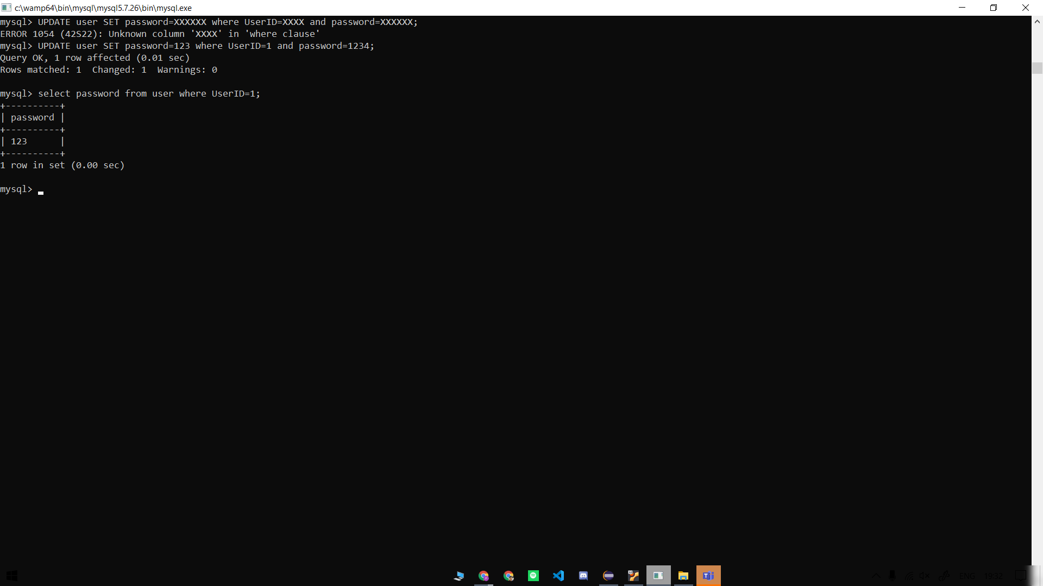

* **Reset donor phone number:**

UPDATE user SET phonenumber=XXXXXX where UserID=XXXX and password=XXXXXX;

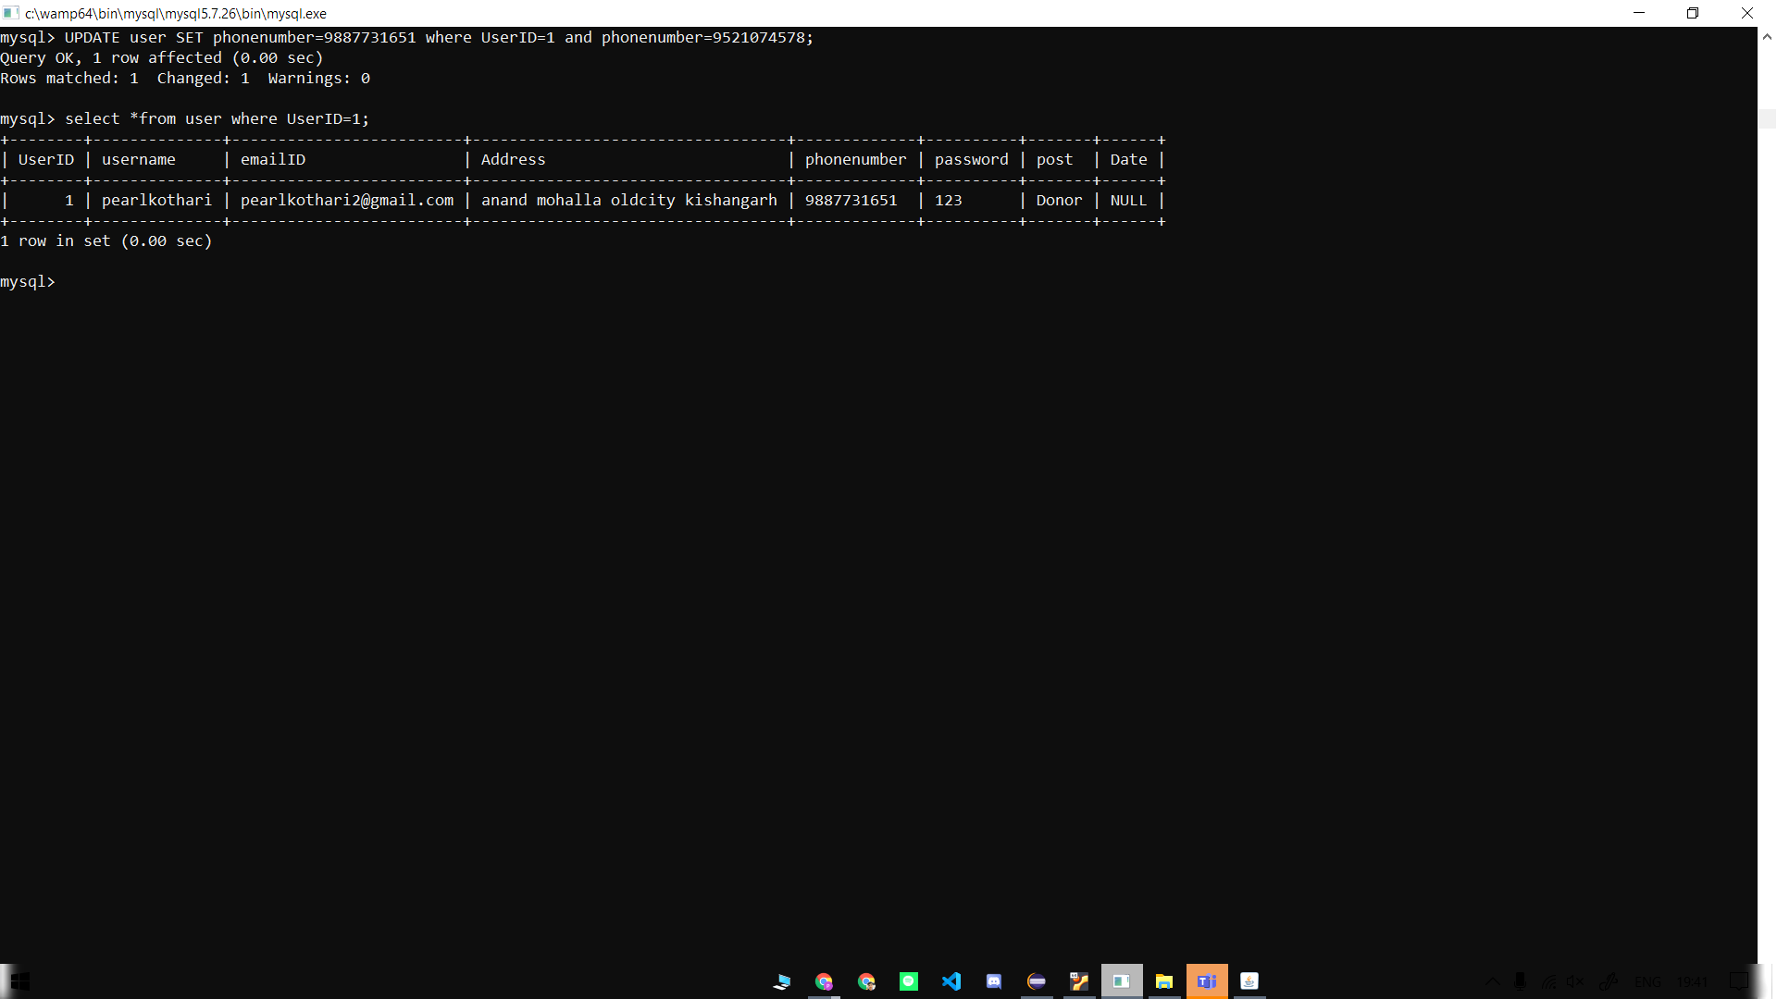

* **Get ID of donor:**

Select UserID from user where phone number=XXXXXXXXXX;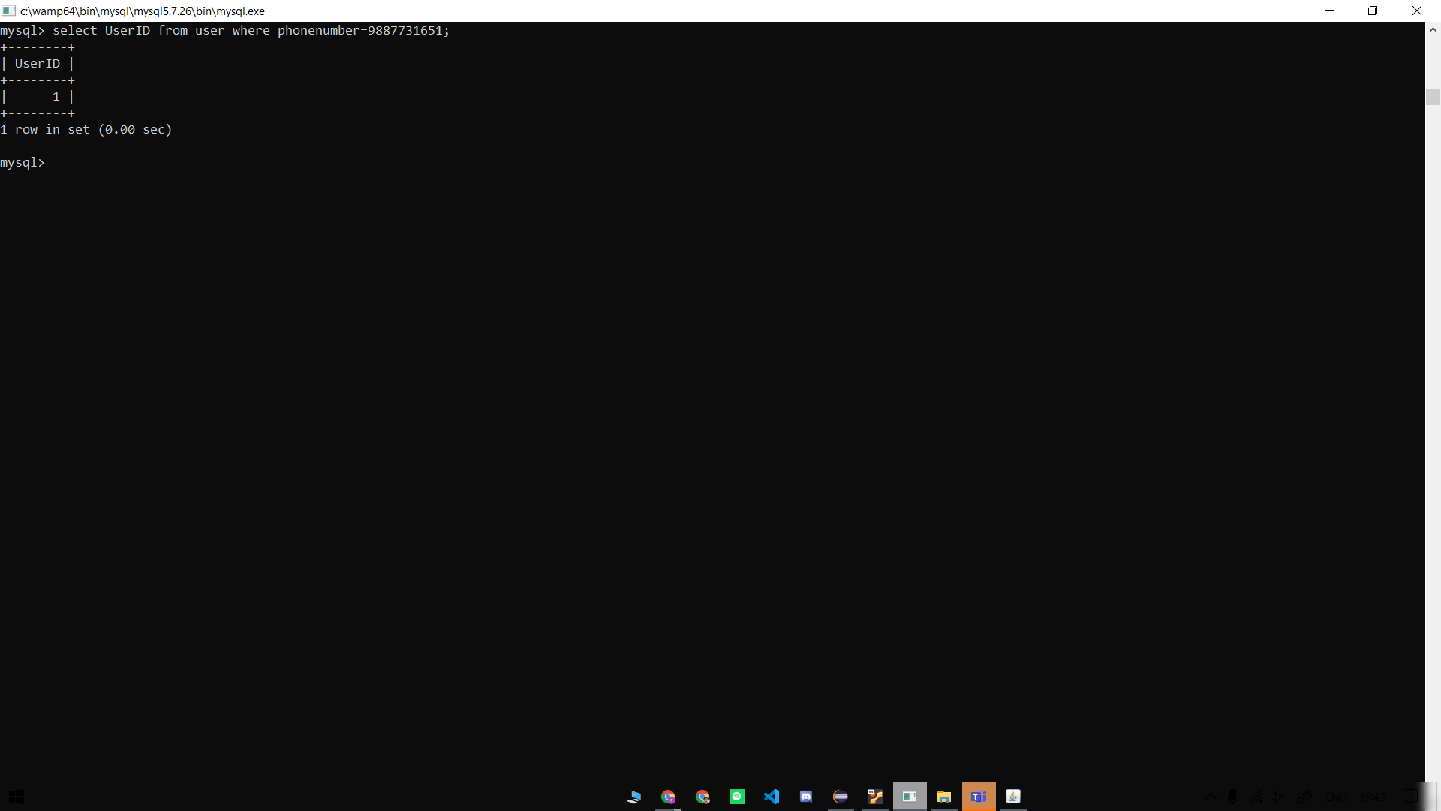

* **ADD donor in donor table:**

insert into donor (UserID,BloodGrp,AnyDisease,phonenumber,Disease,Quantity,Date) VALUES (1,'A+','NO',9509019011,'null','100ml','2020-11-20'),

(2,'AB+','NO',9599919010,'null','50ml','2020-11-20');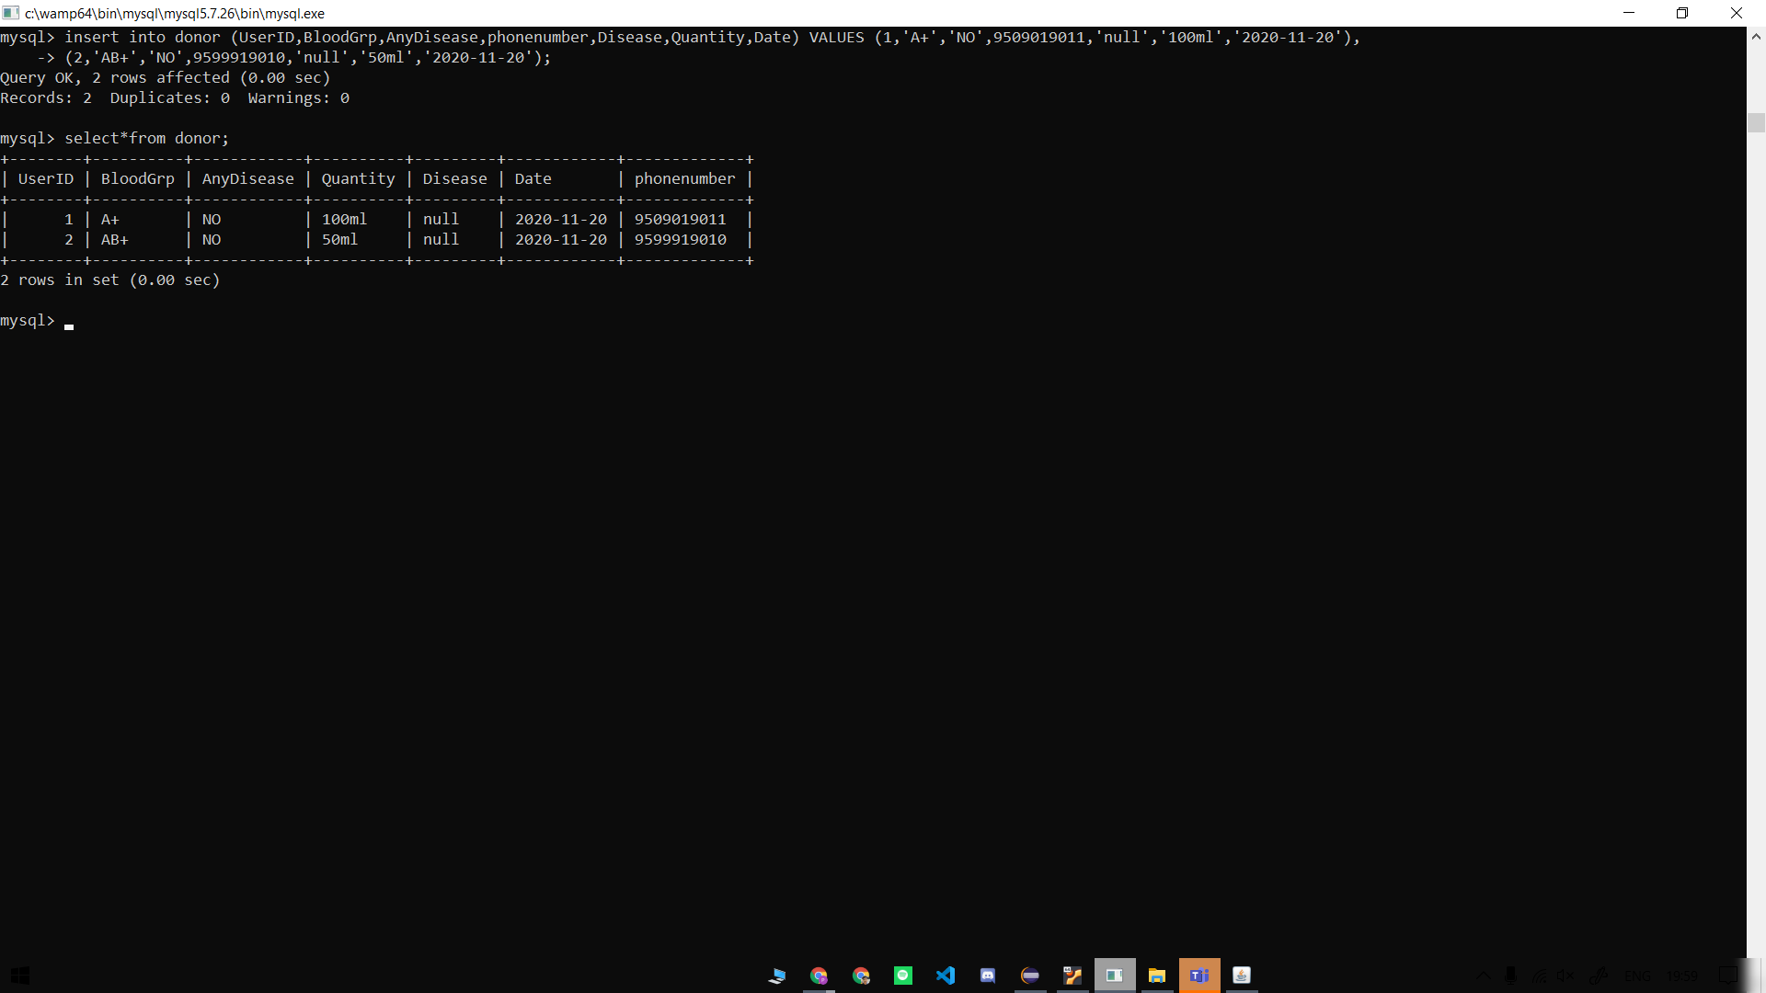

* **Updating Blood Bank Quantity Of BloodGroup:**

For Example: Add 100ml blood in BloodGroup A+

UPDATE bloodbank SET Quantity= NEW_QNT

where BloodGrp=XX;

/*

NEW_QNT = PREV_QNT + SELECTED_QUNT

PREV_QNT is the quantity of blood in the blood bank at the moment before donating/receiving any blood.

SELECTED_QUNT is the quantity of blood donated/received by the user.

*/

For Example:

ADD 100ML “ AB+” Blood

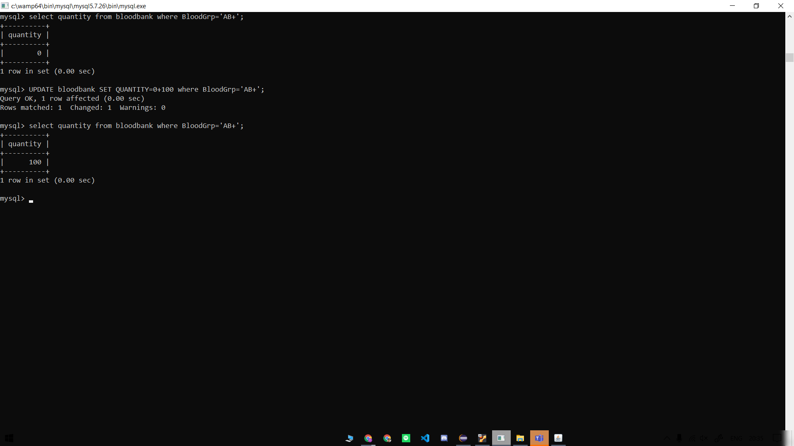

* **Insert into receiver:**

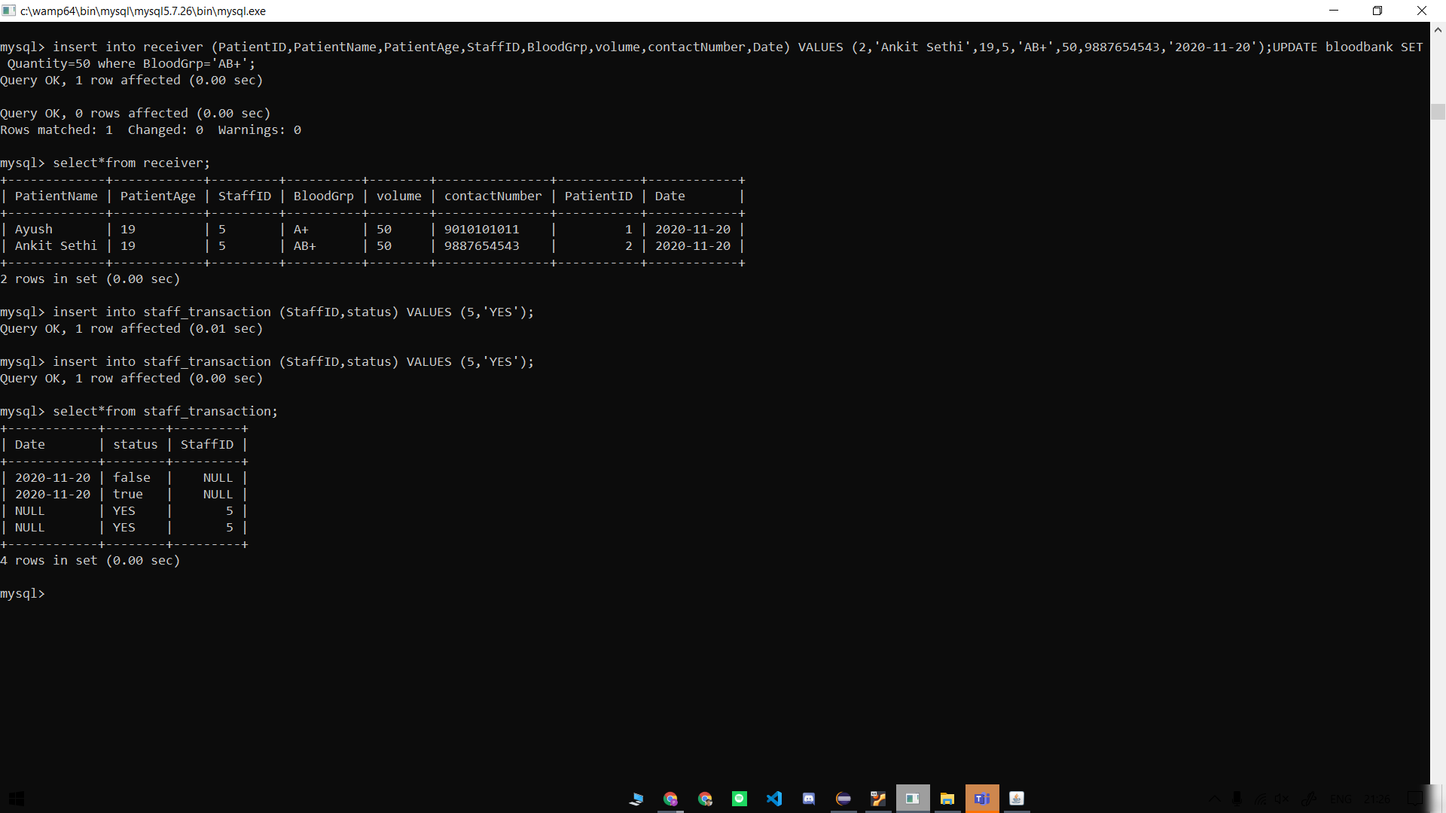

* **Staff_Activity:**

